**CHAPTER 2**

**Review of Related Literature and Studies**

This chapter presents a brief discussion of the literature reviewed by the researchers which further enriched the conceptualization of the study and helped in describing the cognitive design that guided the conduct of the researcher. It deals with theoretical concepts and fundamentals that support this project. This chapter includes the related studies, system and technologies to our proposed system that will help us to for the making of Inventory and ordering system.

**RELATED STUDIES**

**System Components for Online Ordering System**

Online [Ordering System](http://www.nibblematrix.com/complete-online-food-ordering-system/) is a website or mobile application through which users can order food online from a food cooperative or even a native restaurant. Ordering food online is similar to online shopping – buying goods online. Once user places an online order, restaurant receives the order, starts processing it and delivers food to the user.

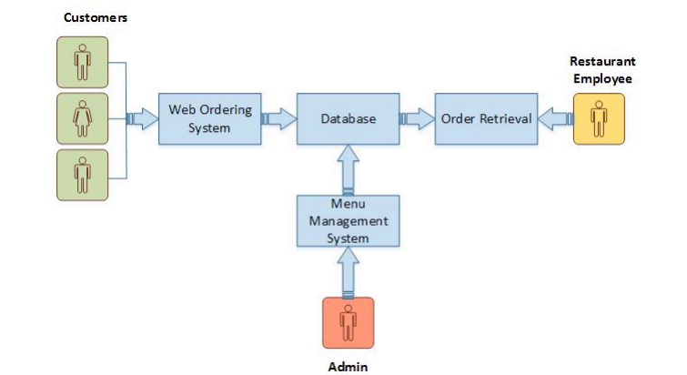

System Components for Online Ordering System

Figure 2.1

The structure of the system can be divided into three main logical components. Web Ordering System provides the functionality for customers to place their order and supply necessary details. Menu Management allows the restaurant to control what can be ordered by the customers. Order Retrieval System is a final logical component because it allows restaurant to keep track of all orders placed. This component takes care of order retrieving and displaying order information.

Web Ordering System Module provides the functionality for customers to place their order and supply necessary details. Users of the system, namely restaurant customers, must be provided the following functionality such create and manage their account, navigate the restaurant’s menu, select and add an item from the menu, review their current order, remove an item, provide payment details, receive confirmation and view order placed.

Menu Management System Module provides functionality for the power user-Administrator only. It will not be available to any other users of the system like Restaurant Employees or Customers. Using a graphical interface, it will allow an Admin to manage the menu that is displayed to users of the web ordering system such as Add/update/delete food category from the menu, update price for a given food item and additional information (description and photo) for a given food item.

Order Retrieval System Module is the simplest module out of all three modules. It is designed to be used only by restaurant employees, and provides the following functions such as retrieve new orders from the database and displays the orders in a readable way.

**System Components for Inventory System**

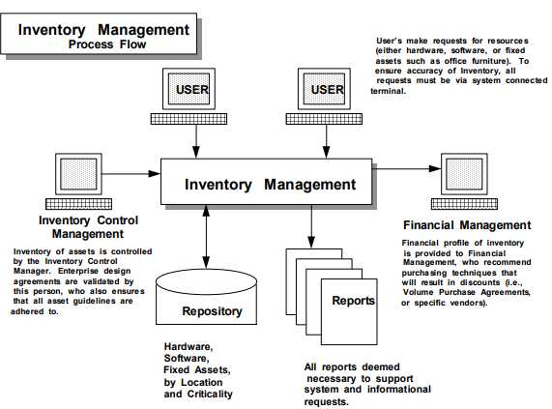

Figure 2.2

Inventory Management System

This figure 2.2 shows the components of an inventory management system. The utilization of Inventory Management Systems to control the purchase and installation of assets can aid in the control of the business environment, while assisting in the assignment of personnel to perform asset related work functions.

To successfully implement an Inventory Management System, it is necessary to integrate it within the everyday functions performed by company personnel. That is, when a user wants to order equipment or software, they would call up the Inventory Management System screen associated with Acquisition. Should a user request the acquisition of a specific type of asset then it would be possible for the inventory system to determine if the asset is already in surplus, or if it should be purchased under an existing Volume Purchase Agreement with a vendor.

**Prototyping**

Prototyping is the process of building a model of a system. In terms of an information system, prototypes are employed to help system designers build an information system that intuitive and easy to manipulate for end users. Prototyping is an iterative process that is part of the [analysis phase](http://www.colorado.edu/infs/jcb/class/analysis.html)of the [systems development life cycle](http://www.colorado.edu/infs/jcb/class/sysdevel.html). (Sauter, 2012).

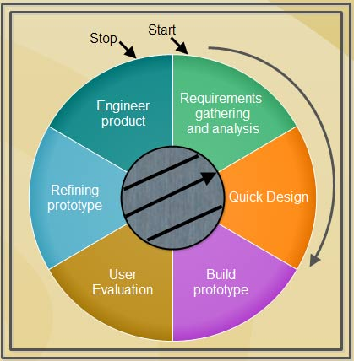

Prototyping Model

Figure 2.3

The prototyping illustrated in Figure 2.3 will be used by the system analyst. A prototyping model begins with requirements analysis and the requirements of the system are defined in detail.

The user is interviewed in order to know the requirements of the system. When requirements are known, a preliminary design or quick design for the system is created. It is not a detailed design and includes only the important aspects of the system, which gives an idea of the system to the user. A quick design helps in developing the prototype.

Information gathered from quick design is modified to form the first prototype, which represents the working model of the required system. Next, the proposed system is presented to the user for thorough evaluation of the prototype to recognize its strengths and weaknesses such as what is to be added or removed. Comments and suggestions are collected from the users and provided to the developer.

Once the user evaluates the prototype and if he is not satisfied, the current prototype is refined according to the requirements. That is, a new prototype is developed with the additional information provided by the user. The new prototype is evaluated just like the previous prototype. This process continues until all the requirements specified by the user are met. Once the user is satisfied with the developed prototype, a final system is developed on the basis of the final prototype.

**Web Application**

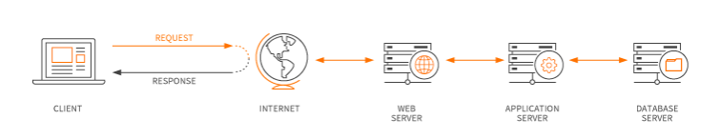

Web Application

Figure 2.4

Figure 2.4 illustrates how the web application utilizes web browsers and web technology to perform tasks over the internet. Web applications are usually coded in browser- supported language such as JavaScript and HTML as these languages rely on the browser to render the program executable. Some of the applications are dynamic, requiring server- side processing. Others are completely static with no processing required at the server.

The web application requires a web server to manage request from the client and then forwards this request to the web application server. Application Server performs the requested task- such as querying the database or processing the data – then generates the results of the requested data that will be sent to the web server. The web server responds back to the client with the requested information that then appears on the user’s display.

**System Testing**

System testing is the type of testing to check the behavior of a complete and fully integrated software product based on the software requirements specification (SRS) document. The system testing will be conducted by the system analyst to evaluate business and end-user requirements. This is black box type of testing where external working of the software is evaluated with the help of requirement documents & it is totally based on Users point of view. For this type of testing do not required knowledge of internal design or structure or code.

 In Software Development Life Cycle the System, testing is perform as the first level of testing where the system is tested as a whole to check if system meets functional requirement or not. System Testing enables you to test, validate and verify both the Application Architecture and Business requirements. The System is tested in an environment that particularly resembles the effective production environment where the application will be lastly deployed.

**­Related System­­­­**

The systems that will be shown in Related System are the Ordering and Inventory systems that are related to the project. The following related system will benefit and help the analysts develop the system prototype.

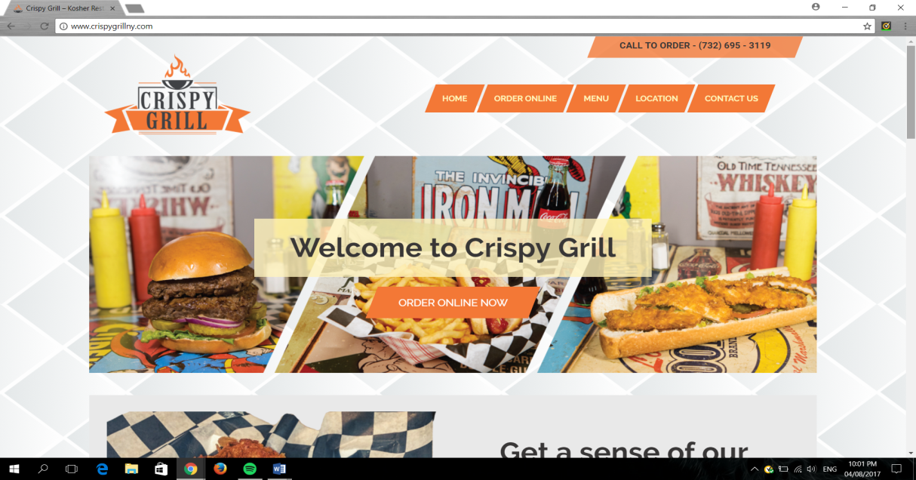

Figure 2.5

Homepage of Crispy Grill

Figure 2.5 is the screenshot of Crispy Grill’s Online Ordering System for their customers. The homepage is the most important part of the website and it serves as table of contents to the customer.

The first thing that the customers will see is the greeting of Crispy Grill to them. This content will show the customers the important details of their restaurant like Order Online, Menu, Location and Contact Us and the automatic display of their telephone number that will guide and help them in ordering online.

In contrast between Crispy Grill and The Cuckoo Chef Restaurants, they both have the same functionalities. In comparison, the design and appearance of Crispy Grill will be different with the Cuckoo Chef Restaurant.

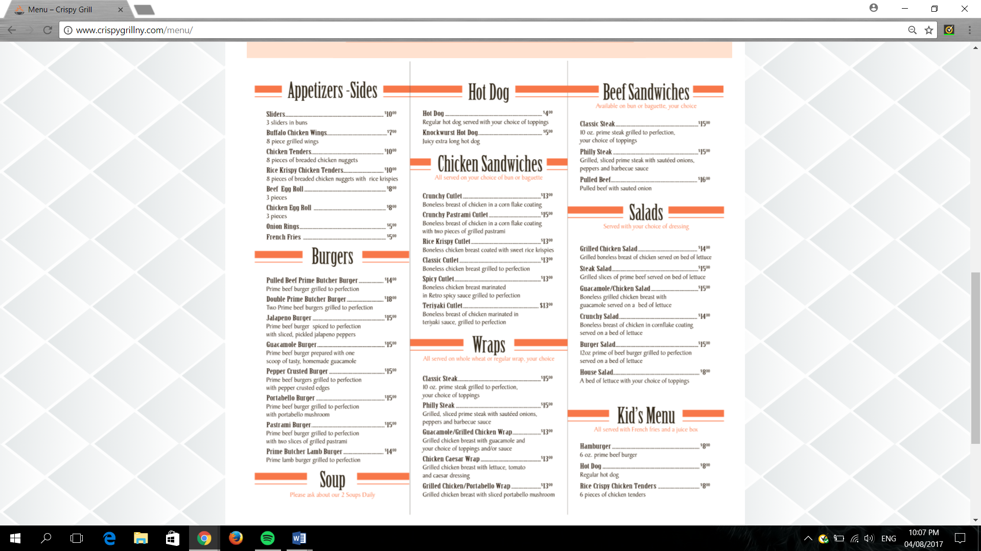

Figure 2.6

Crispy Grill’s Menu

Figure 2.6 are the screenshot of main menu and promotion of Crispy Grill. This interface shows all the food that Crispy Grill offers. American-inspired foods is the style of foods that they offer.

The difference of Crispy Grill’s menu with the menu of The Cuckoo Chef Restaurant are the listing of foods and the costings. The Cuckoo Chef Restaurant will have burgers, tacos, wings ,pizza, burger, salads, pasta, beverage like beer, alcohol, shakes and so on on the list of the menu, since the Crispy Grill is more on American-styled food, the Cuckoo Chef Restaurant is *tex-mex* (texan-mexican) style. The design and theme of Crispy Grill will also be different with The Cuckoo Chef Restaurant to make the appearance better for the customers.

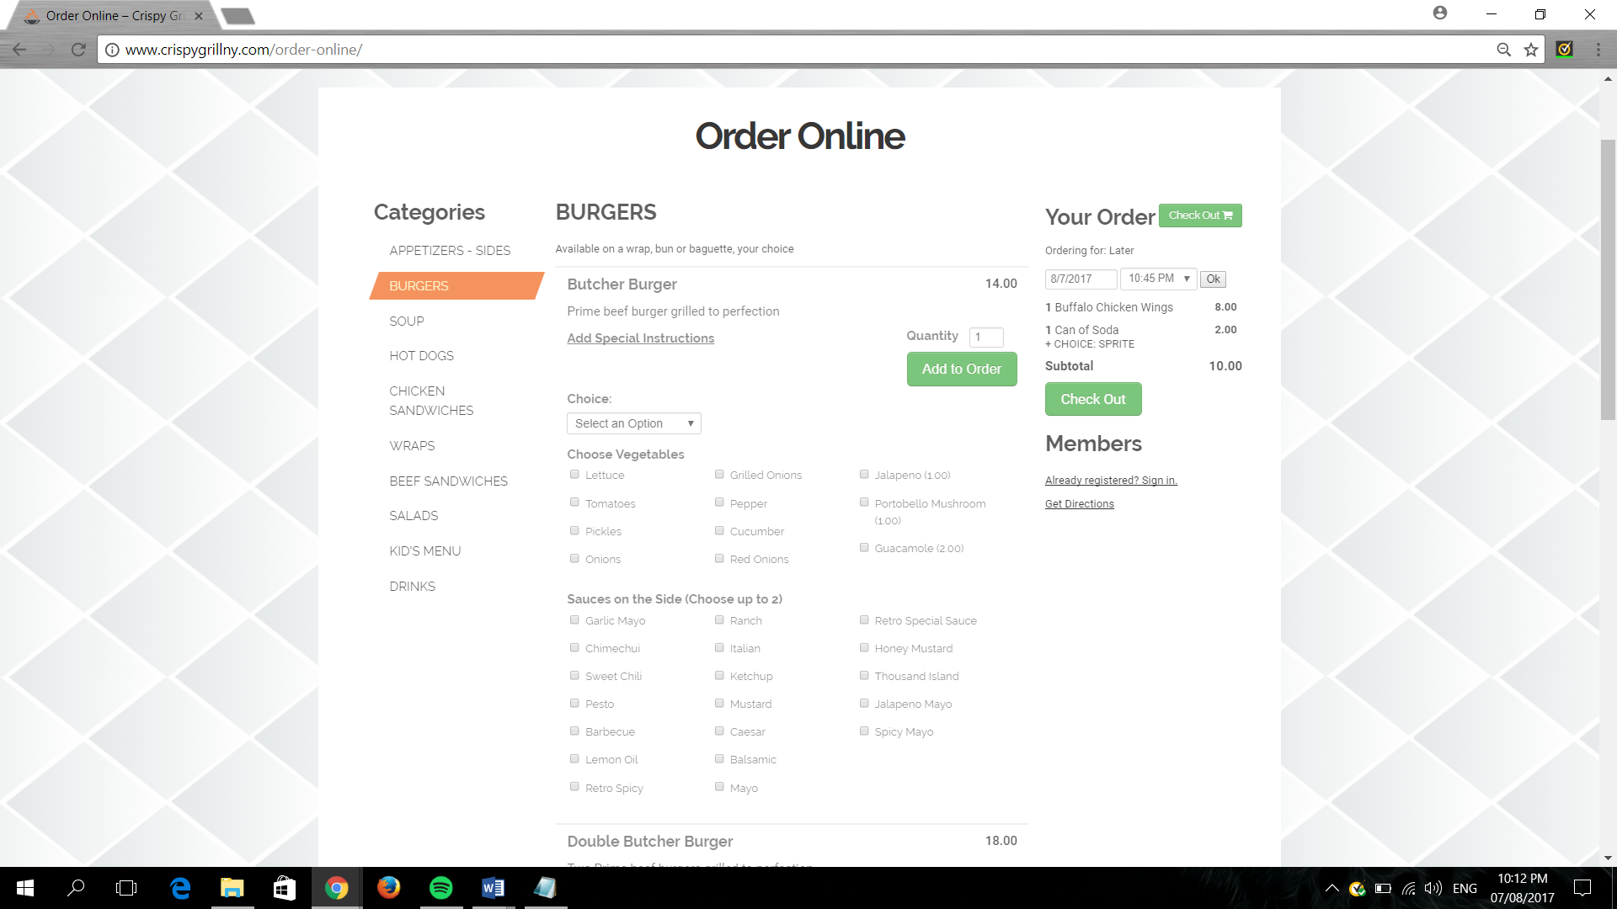

Figure 2.7

Order Online Interface

This screenshot interface shown in Figure 2.7 is the online ordering part of Crispy Grill. This interface shows the ingredients that will be added on the order of the customer.

Other options is also applied on other foods like flavors, sauces and so on. The customer has the freedom to add what they desire to achieve their satisfaction.

Having options of ingredients, flavors, sauces and so on to choose in the Crispy Grill restaurant will also be the same with the Cuckoo Chef Restaurant’s online ordering. The similairty of proposed system to Crispy Grill, The Cuckoo Chef Restaurant will also have the options for customizations of customer’s order online.

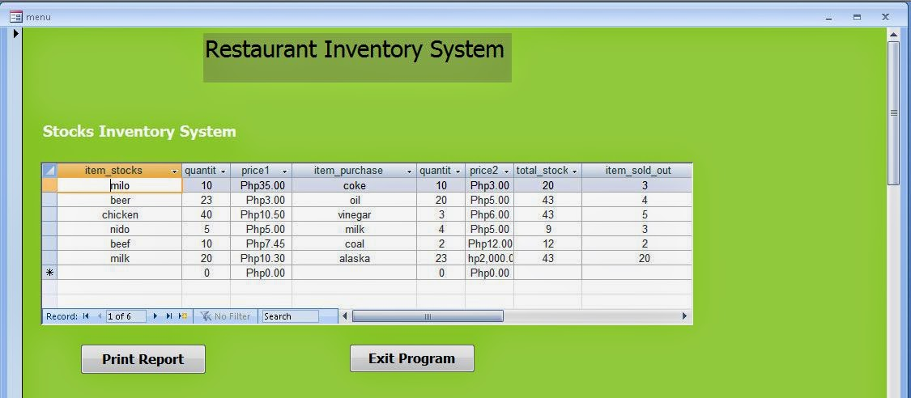

Figure 2.8

Inventory System Interface of Restaurant Inventory System

The inventory system shown in figure 2.8 displays the stock items, stock quantity, stock units, items sold out which displays what has the highest demand product and etc of the inventory system. it is designed for admin to keep updated and keep in track the stocks on hand of the restaurant.

This interface is only accessible by the administrator/s to see the contents of the inventory. Administrator/s can input, edit, delete and update the information of the stocks. With the use of the Restaurant Bistro’s inventory system, the administrator/s can view the stocks easily by sorting in alphabetical or by location and choosing other categories depending on which type of food the admin wants to access or view and the administrator/s can also see the best-selling product by viewing the items sold out.

Some of the feature of the Restaurant invetory system will be used in The Cuckoo Chef Restaurant like the quantity and unit of the stocks and items sold out except for the unit price and the value.

Features like items sold out, stock, and quantity are the prior needs of The Cuckoo Chef Restaurant to keep in track in the inventory system to supply the orders of the customers that is why the Restaurant Inventory System’s feature is important to help the Cuckoo Chef Restaurant inventory system track and be updated with the supplies.

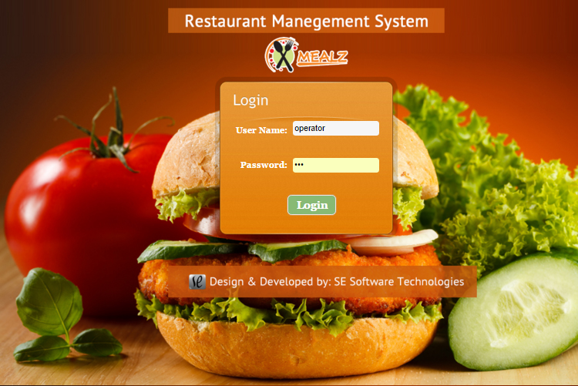

Figure 2.9

Admin Log in Page Interface

The log in page interface shown in figure 2.9 shows the username and password of the admin and other people who has authorization to access the inventory. Log in page is one of the important content of accessing inventory system, it provides strong security to avoid hackers by hacking the system and avoids the employee to access the inventory.

This interface can access the inventory system with the use of administrator/s username and password. It is designated to protect the important details of the inventory that is only meant for the administrator/s.

The Cuckoo Chef Restaurant is important to have log in page in the inventory system to protect the stocks from employee theft and other system security problems. Log in Page will help the admin to have the privacy in accessing the inventory.

**RELATED TECHNOLOGY**

**Data Manipulation/Data Query Language: My SQL**

**My SQL**

MySQL is an open source relational database management system based on Structured Query Language . MySQL runs on virtually all platforms, includingLinux, UNIX, and Windows. Although it can be used in a wide range of applications, MySQL is most often associated with web-based applications and online publishing and is an important component of an open source enterprise stack called LAMP. LAMP is a Web development platform that uses Linux as the operating system, Apache as the Web server, MySQL as the relational database management system and PHP as the object-oriented scripting language. We are comfortable to use this kind of programming languange because we used a lot this one in are major subject.

**Web design / Web Authority**

**Adobe Dreamweaver cs5**

Dreamweaver remains one of the most popular professional web design programs available. It offers a lot of power and flexibility for both designers and developers. There are a lot of features, which can make it intimidating, but in general, it is easy to pick up and start using and the advanced features make it possible to go from beginning web designer to professional in a very short period of time.

Dreamweaver is a WYSIWYG editor and code editor for Windows and Macintosh. Users can use it to write HTML, CSS, JSP, XML, PHP, JavaScript, and more. It can read WordPress, Joomla!, and Drupal templates and it includes [a grid system](https://www.thoughtco.com/use-grid-system-in-graphic-design-1697574) to do grid-based responsive layouts for three different device sizes at once. Plus, Dreamweaver offers a lot of tools for doing mobile web development including creating native apps for iOS and Android devices.

The System analyst use this to design the Web page of the Cuckoo Chef Restaurant, to get more customer with the help of this new technology

**Scripting language**

**PHP**

PHP is a [server-side scripting](https://en.wikipedia.org/wiki/Server-side_scripting) language designed primarily for [web development](https://en.wikipedia.org/wiki/Web_development) but also used as a [general-purpose programming language](https://en.wikipedia.org/wiki/General-purpose_programming_language). Originally created by [Rasmus Lerdorf](https://en.wikipedia.org/wiki/Rasmus_Lerdorf) in 1994, the PHP [reference implementation](https://en.wikipedia.org/wiki/Reference_implementation)is now produced by The PHP Development Team. PHP originally stood for Personal Home Page, but it now stands for the [recursive acronym](https://en.wikipedia.org/wiki/Recursive_acronym) PHP: Hypertext Preprocessor.

PHP code may be embedded into [HTML](https://en.wikipedia.org/wiki/HTML) or HTML5 [markup](https://en.wikipedia.org/wiki/Markup_language), or it can be used in combination with various [web template systems](https://en.wikipedia.org/wiki/Web_template_system), [web content management systems](https://en.wikipedia.org/wiki/Web_content_management_system) and [web frameworks](https://en.wikipedia.org/wiki/Web_framework). PHP code is usually processed by a PHP [interpreter](https://en.wikipedia.org/wiki/Interpreter_(computing)) implemented as a [module](https://en.wikipedia.org/wiki/Plugin_(computing)) in the web server or as a [Common Gateway Interface](https://en.wikipedia.org/wiki/Common_Gateway_Interface) (CGI) [executable](https://en.wikipedia.org/wiki/Executable). The [web server](https://en.wikipedia.org/wiki/Web_server) software combines the results of the interpreted and executed PHP code, which may be any type of data, including images, with the generated [web page](https://en.wikipedia.org/wiki/Web_page). PHP code may also be executed with a [command-line interface](https://en.wikipedia.org/wiki/Command-line_interface) (CLI) and can be used to implement [standalone](https://en.wikipedia.org/wiki/Computer_software) [graphical applications](https://en.wikipedia.org/wiki/Graphical_user_interface).The standard PHP interpreter, powered by the [Zend Engine](https://en.wikipedia.org/wiki/Zend_Engine), is [free software](https://en.wikipedia.org/wiki/Free_software) released under the [PHP License](https://en.wikipedia.org/wiki/PHP_License). PHP has been widely ported and can be deployed on most web servers on almost every [operating system](https://en.wikipedia.org/wiki/Operating_system) and [platform](https://en.wikipedia.org/wiki/Computing_platform), free of charge.

The System analyst used this programming language for the web development of the Inventory and Ordering System of the Cuckoo Chef Restaurant**.**

**Query language**

**My Sql**

MySQL is an open source relational database management system (RDBMS) based on Structured Query Language (SQL). LAMP is a Web development platform that uses Linux as the operating system, Apache as the Web server, MySQLas the relational database management system and PHP as the object-oriented scripting language.

The System Analyst used this to hold the data from the database system of the Cuckoo Chef Restaurant.

**Web Design**

**Adobe Photoshop**

**Adobe Photoshop** is the predominant photo editing and manipulation software on the market. Its uses range from full featured editing of large batches of photos to creating intricate digital paintings and drawings that mimic those done by hand.

The System Analyst used this to design the web page of the Cuckoo Chef Restaurant page to be more attractive to the customer.

**Web-based Ordering and Inventory System for The Cuckoo Chef Restaurant**

Members:

* Baldoza ,Rhenj Gabriel (PM)
* Flores ,Azalea
* Petate ,Ellaira
* Panganiban ,Vincent